Data logger Manual

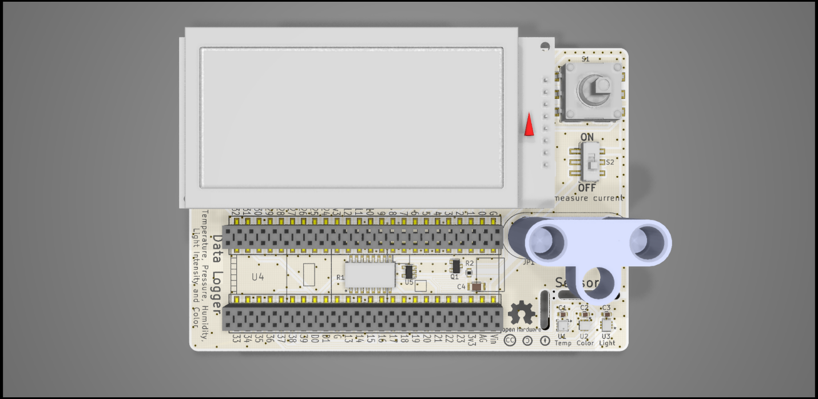

Board ordering

To build the data logger, you will need a PCB board. To greatly ease assembly, you will also want a solder paste stencil. Both of these can be easily ordered by submitting the Gerber files to a PCB and stencil fabricator. Several such vendors include Aisler, PCBWay, JLCPCB, etc.

Board specifications:

Size: 69 x 100 mm

Board: 1.6 mm FR4

Copper : 1 oz/ft2

Surface finish: HASL with lead or ENIG

Vias: Tented

Stencil specifications:

Type: Non-framework (unless you have a stencil printer: <http://www.madelltech.com/m2-4.html>)

Electropolishing: Yes (this is essential to prevent the solder paste from sticking onto the stencil)

Parts ordering

Parts can be easily ordered by submitting the bill-of-materials ([Data logger BOM.xlsx](https://github.com/Llamero/Light_Color_and_Intensity_Datalogger/blob/master/Data%20logger%20BOM.xlsx)) to any major parts vendor including Digikey (<https://www.digikey.com/bom>) or Mouser (<https://www.mouser.com/bom/>). The BOM is setup to automatically calculate the number of parts needed based on the number of boards specified.

Equipment needed:

Tape

Single edge razor blade

Disposable stirrer (pipette tips work well)

Soldering iron

Solder

Solder paste

Solder flux

Magnifying glass or microscope

Tweezers or forceps

Thermometer

Hot plate

Hot glue gun

Aluminum foil

Disposable latex or nitrile gloves

70% Ethanol or rubbing alcohol

Optional: Container for pre-sorting components

Soldering the board

Before starting with assembly of the board be sure to read and understand all of the following instructions. Once the solder paste is applied the board must be reflowed within two hours or too much of the flux will evaporate. Also be sure to change your gloves regularly during the application of the solder paste. Solder paste can readily get into the skin, posing a health hazard. Hazards aside, assembling a PCB board is very much akin to building a model or advanced Lego® kit with no advanced skills required. Here is an additional tutorial on solder paste stenciling (<https://www.sparkfun.com/tutorials/58>) and reflow (<https://www.sparkfun.com/tutorials/59>).

# Step 1: Tape PCB boards together

You want to tape the board to another PCB board so that the stencil can be attached to a flat surface.

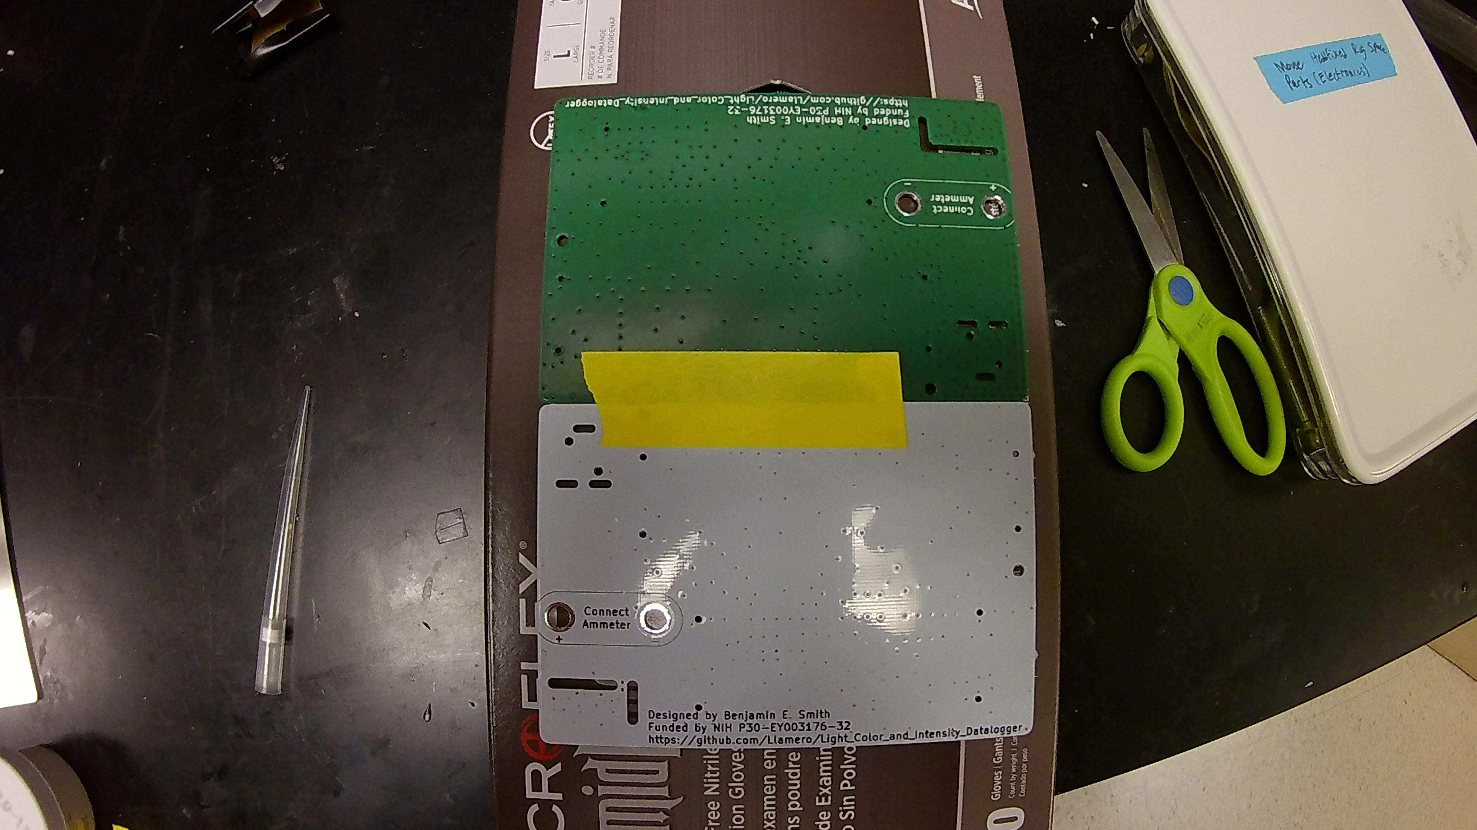

# Step 2: Align stencil onto PCB

Using a microscope or magnifying glass, try to align the stencil as accurately as possible with all of the stencil holes lining up with all of the PCB pads. Small errors (less than half a pad spacing) are tolerable as the solder will wick to the correct position, but the more aligned the better. The sensor pads are the most closely spaced, so be extra careful to align them properly.

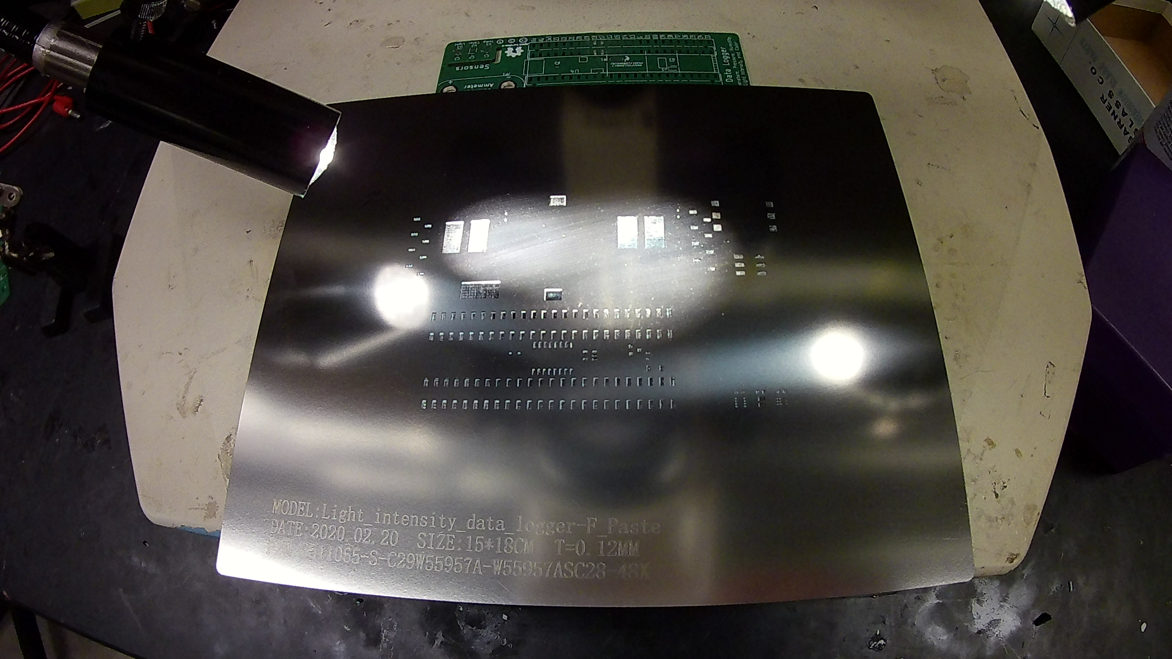

# Step 3: Tape stencil in place onto spare PCB

Carefully tape the stencil into place, and then press down the on the stencil to check the alignment. Repeat steps 2-3 if the stencil looks off center.

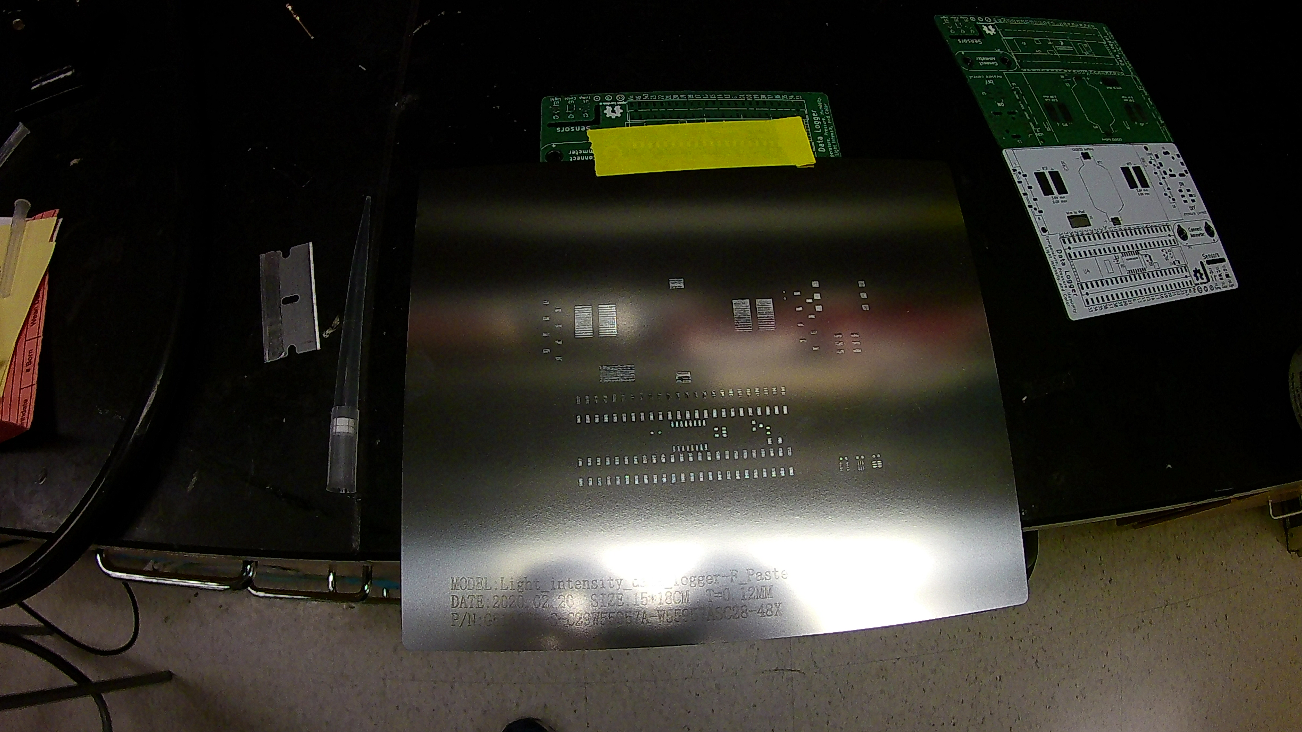

# Step 4: Thoroughly mix the solder paste

Put on a pair of disposable gloves and vigorously mix the solder paste with a disposable stirrer (such as a pipette tip) for at least one minute. Inadequately mixed solder paste can lead to poor solder reflow.

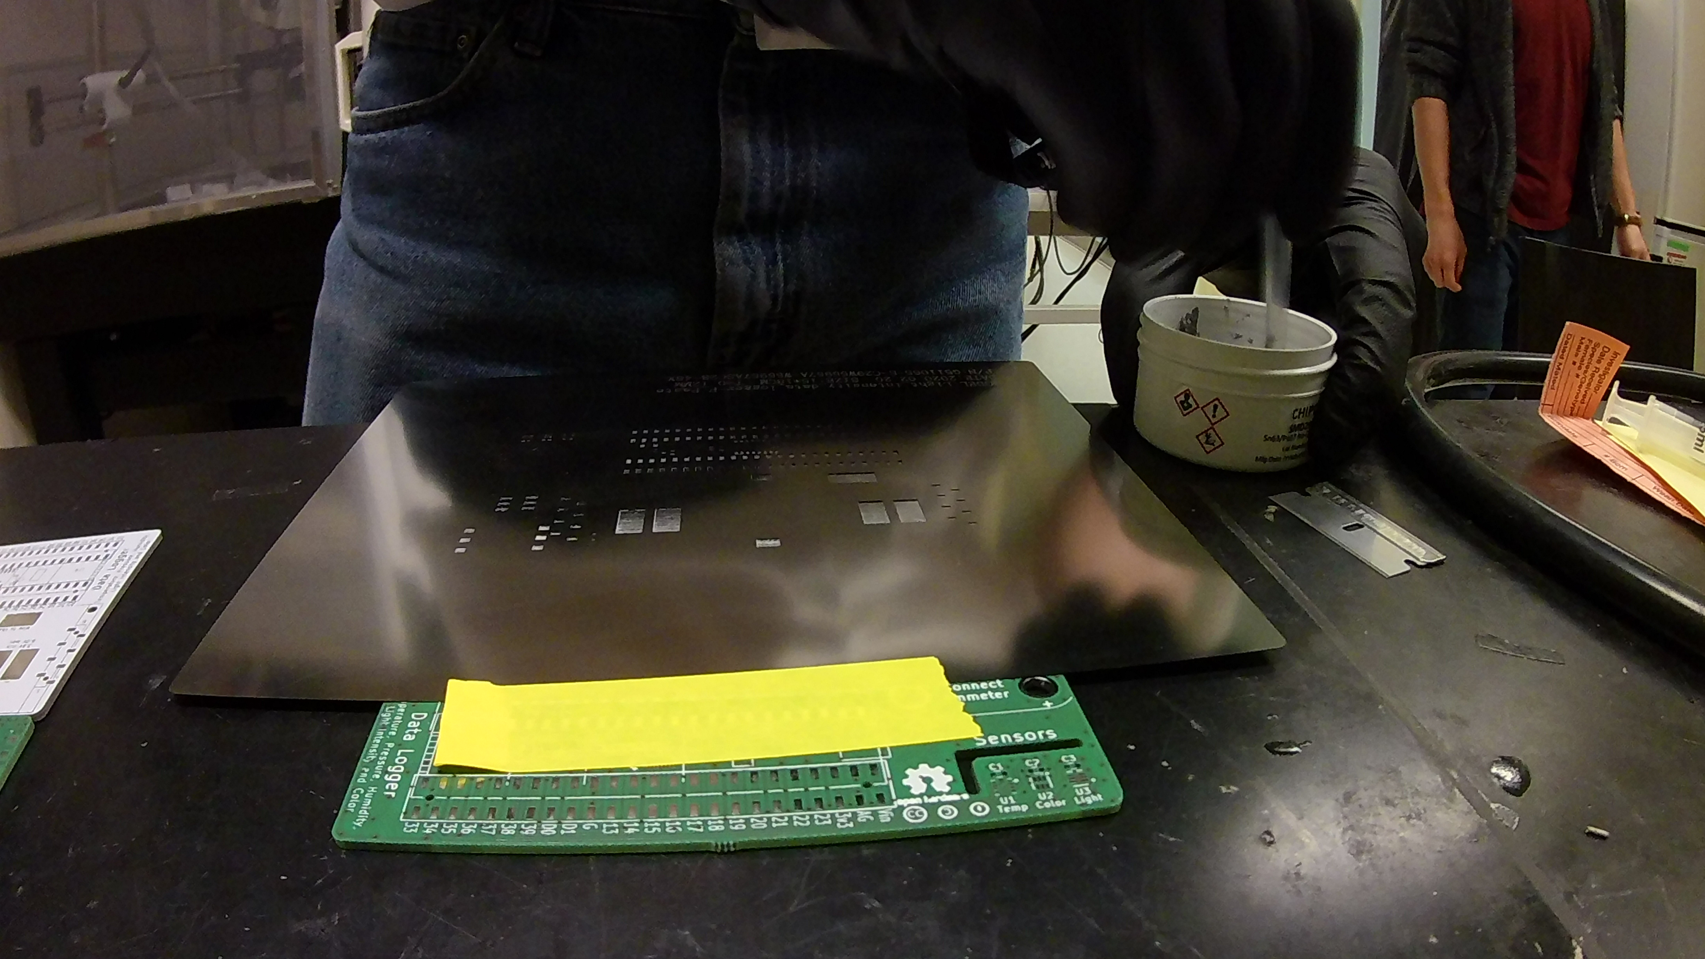

# Step 5: Apply solder paste to the razor blade

Using the stirrer to apply a generous amount of solder paste to the blade edge of the razor blade.

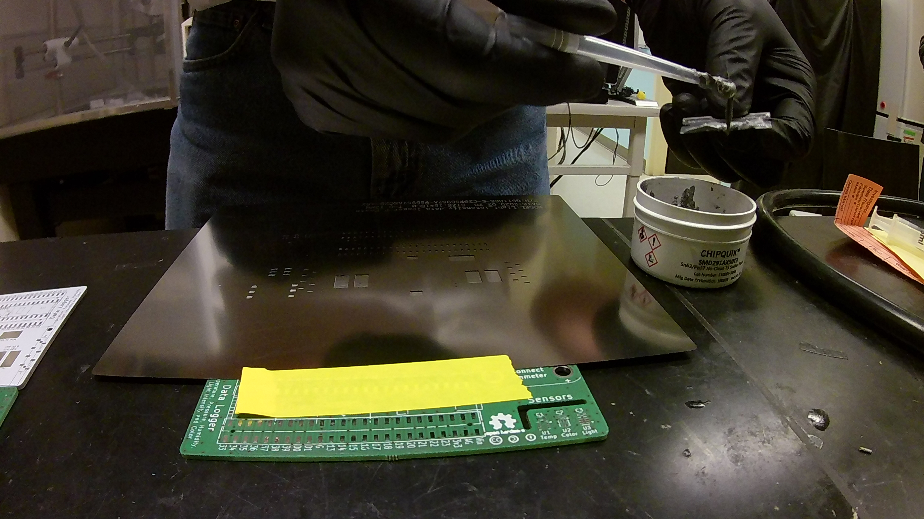

# Step 6: Apply thick layer of solder paste to the stencil

Use the razor blade to apply a coat of solder paste to the stencil, ensuring you cover all of the pads. Try to move across the stencil at a 45° angle to reduce the risk of pressing paste under the stencil. It will likely take multiple applications to cover the entire stencil.

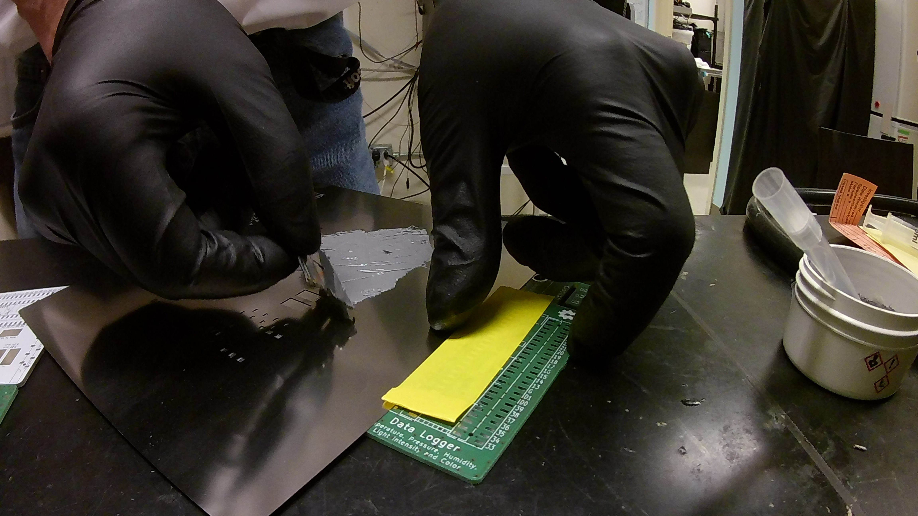

# Step 7: Remove all excess solder paste

Press the razor blade onto the stencil and carefully scrape off all of the excess solder paste. Use the stirrer to remove the excess paste from the blade and return it to the solder paste container.

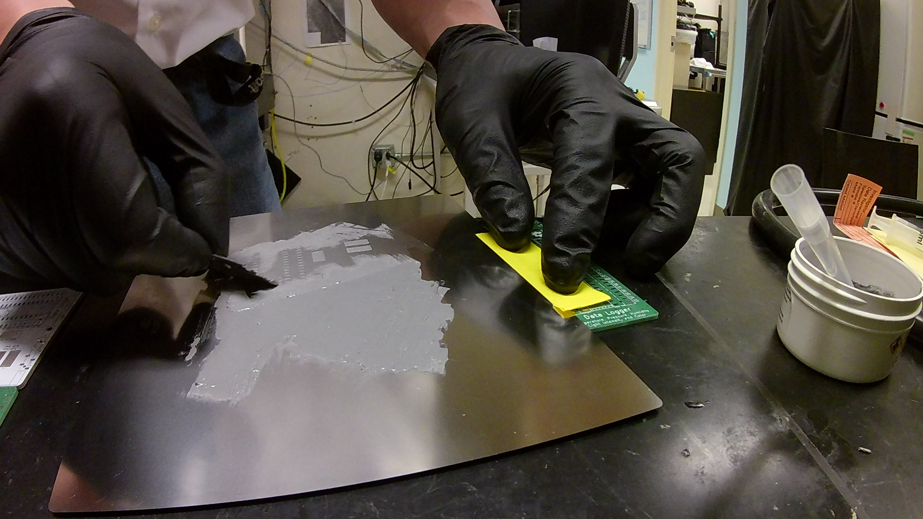

# Step 8: Lift the stencil from the PCB board

Once all of the excess paste is removed from the stencil, lift the stencil from the PCB by pulling up on the side opposite the tape. Once the stencil is clear of the PCB, carefully remove the tape from the stencil and PCB, and remove the spare PCB the stencil was attached to. Inspect the PCB to make sure all the pads are covered in solder paste, and then properly dispose of the blade and stirrer, and clean the stencil thoroughly with 70% ethanol or rubbing alcohol. Also return the solder paste to 4°C storage.

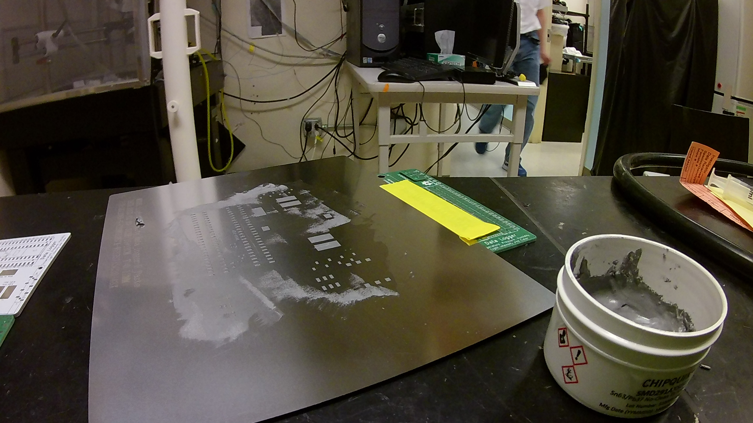

# Step 9: Add components to the PCB board

Using forceps, carefully place each component onto the board. All components should have a numerical identifier on the BOM (such as “R1”) that corresponds to a marking on the board. Chips that have a specific orientation will have a dot next to pin #1, and there is as asterisk next to the corresponding pad on the PCB. Diodes should be aligned such that the line on the diode goes into the U shaped mark on the PCB: The light sensors are an exception since the epoxy cover is clear. For these chips, pin #1 is marked by a pad that is thinner than the other pads (see picture below – the green arrow points to the pin #1 pad which is thinner than the other three corner pads – magenta arrows). Do not add the joystick (S1) as this will be hand soldered on later.

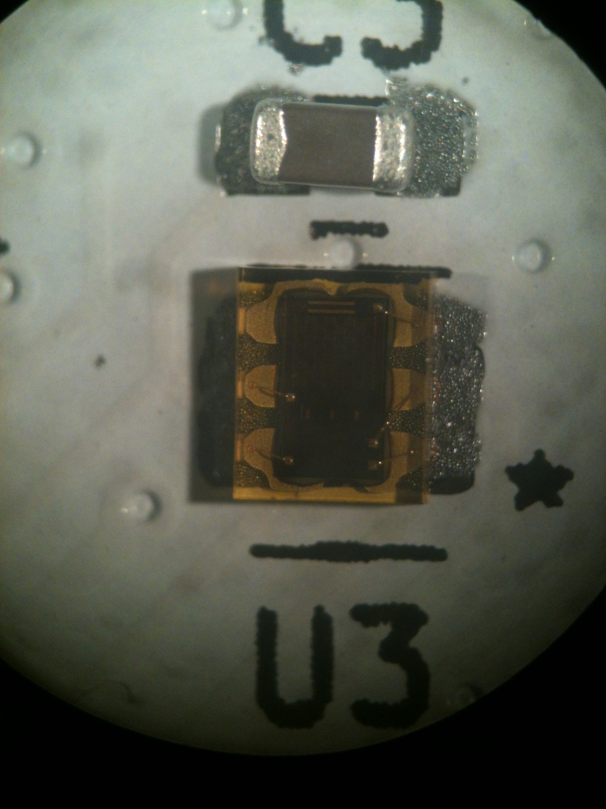

# Step 10: Reflow the board

Once all of the parts are placed, double check all the components to make sure they are oriented properly, then transfer the board onto a piece of aluminum foil, and place the boards onto a hot plate. Make sure the hot plate is near a fume hood or is in a well ventilated area, as the flux will fume as it burns off. Turn on the heat to the hot plate and monitor the temperature with the thermometer. If you are using lead solder paste, the solder should melt at 183°C. Continue heating the board to around 220°C, and make sure that all of the solder has melted. Since the solder is under the sensors, you can gently tap the sensor chips with a pair of forceps. If they snap back, the solder has melted. Carefully lift the aluminum foil with the boards off of the hot plate, and allow them to cool.

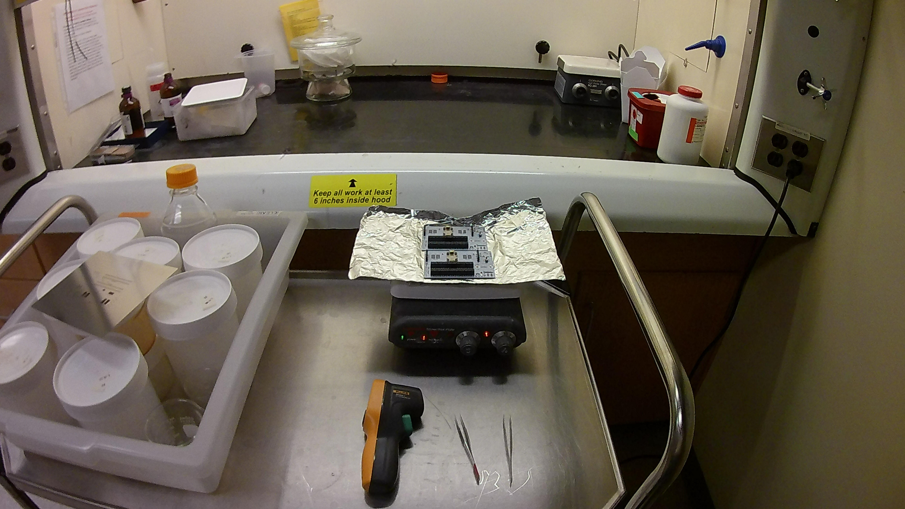

# Step 11: Inspect the board

Once the boards have cooled, inspect all of the solder joints to make sure they reflowed properly. All joints should look shiny. If you see dull joints, these have not fully reflowed, so apply a small amount of flux to the joint and melt it with a soldering iron. Solder bridges (two or more pins soldered together) can be easily removed by applying a small amount of flux to the bridge, and then tapping the bridge with a clean soldering iron.

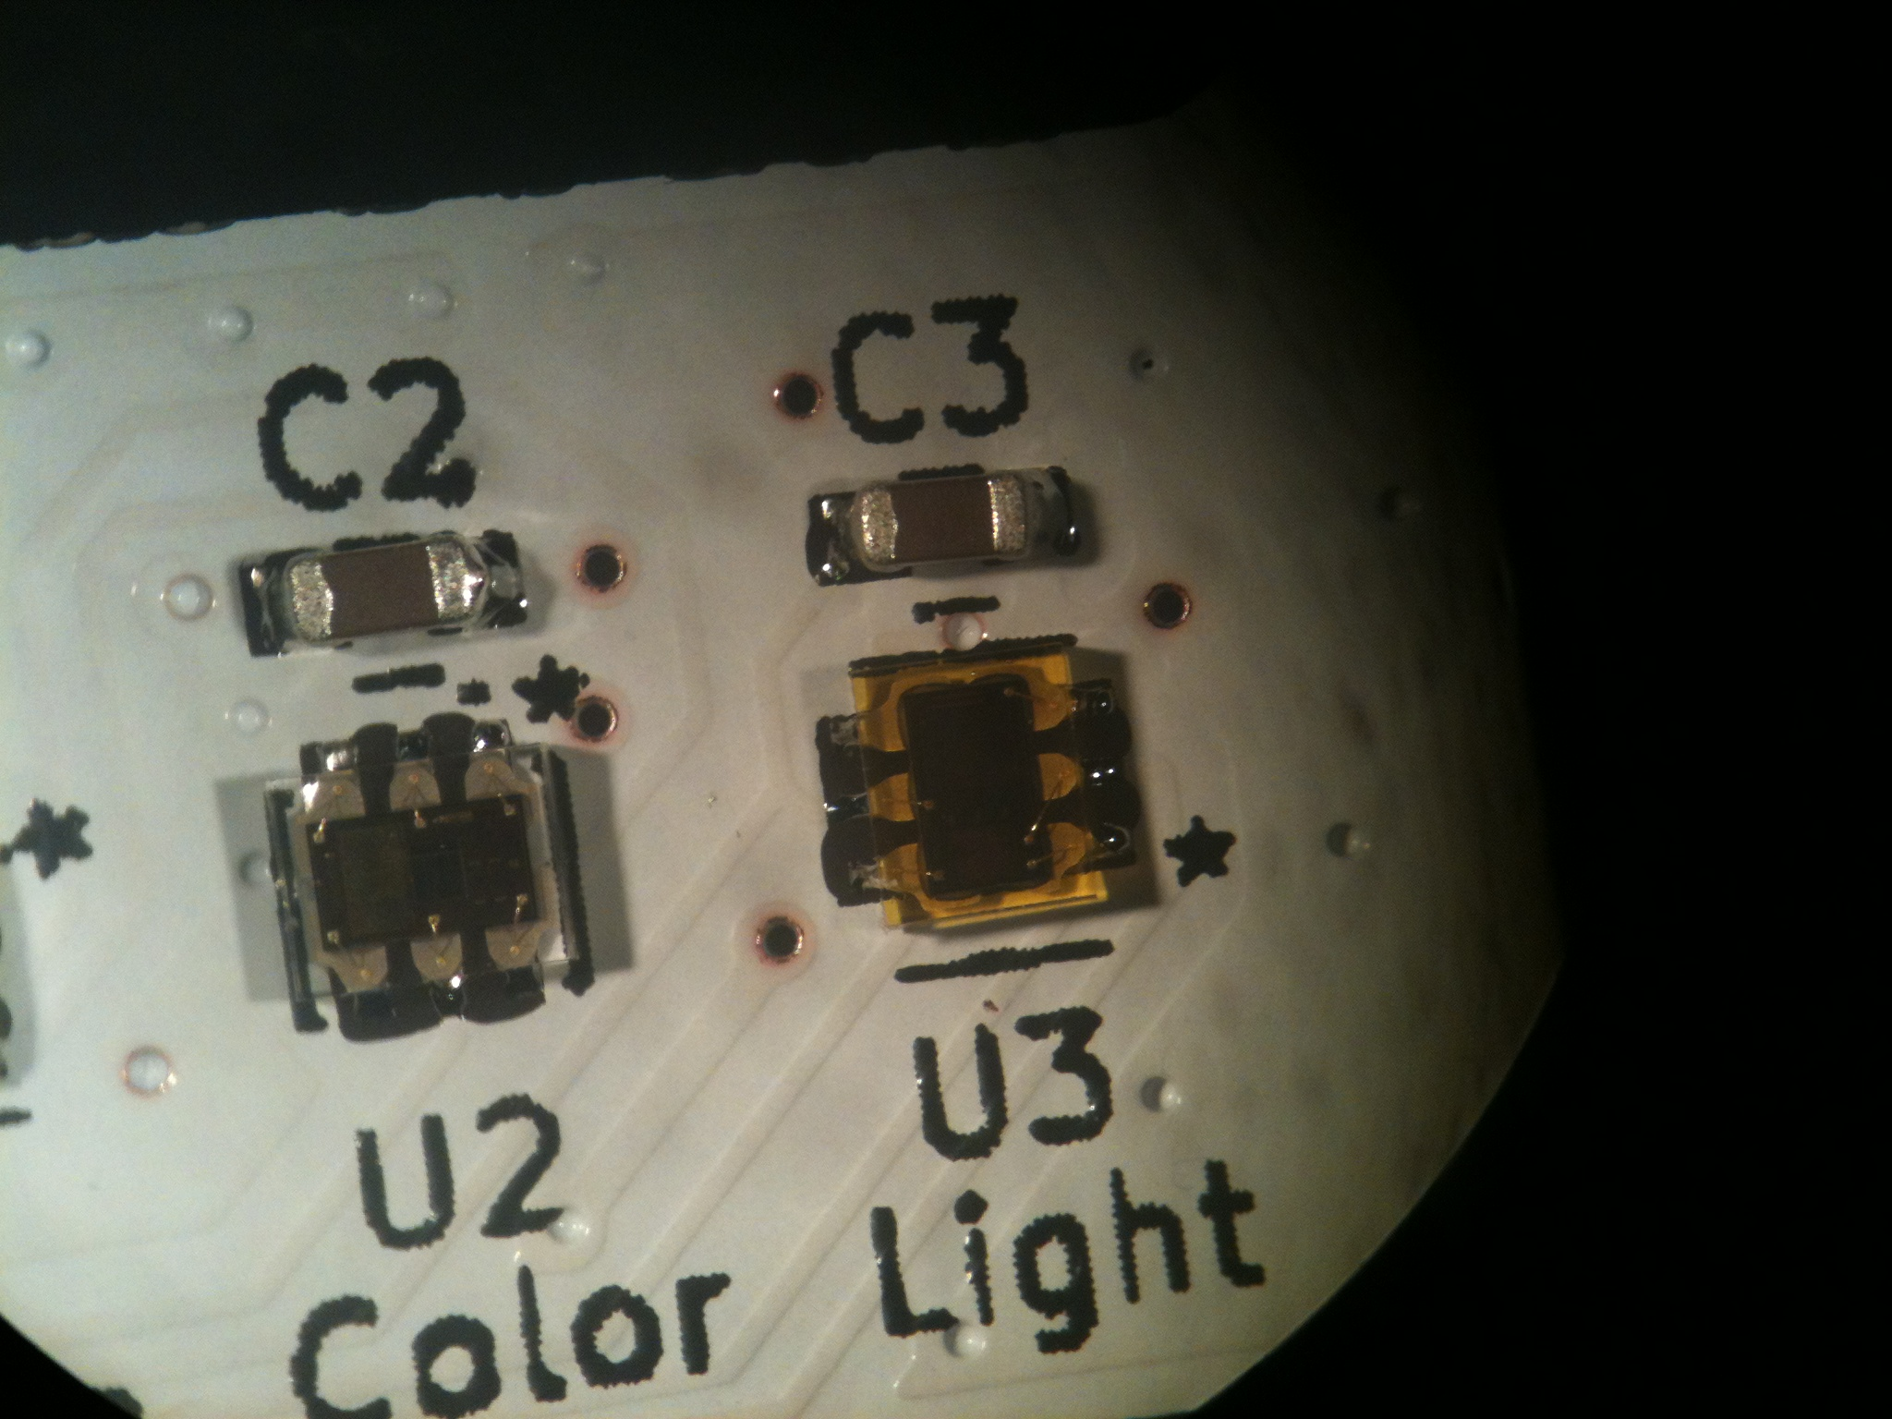

# Step 12: Solder the joystick onto the board and drill the battery pack

Place the joystick into its corresponding slot on the board, and hand solder each pin to the board. You can also add the CR2032 battery at this time. Optional: If you want to use banana clips to test the data logger current usage, place the battery pack under the board, and trace the two banana clip through holes onto the battery pack. Then drill the corresponding holes ( >4.5 mm in diameter) into the battery pack.

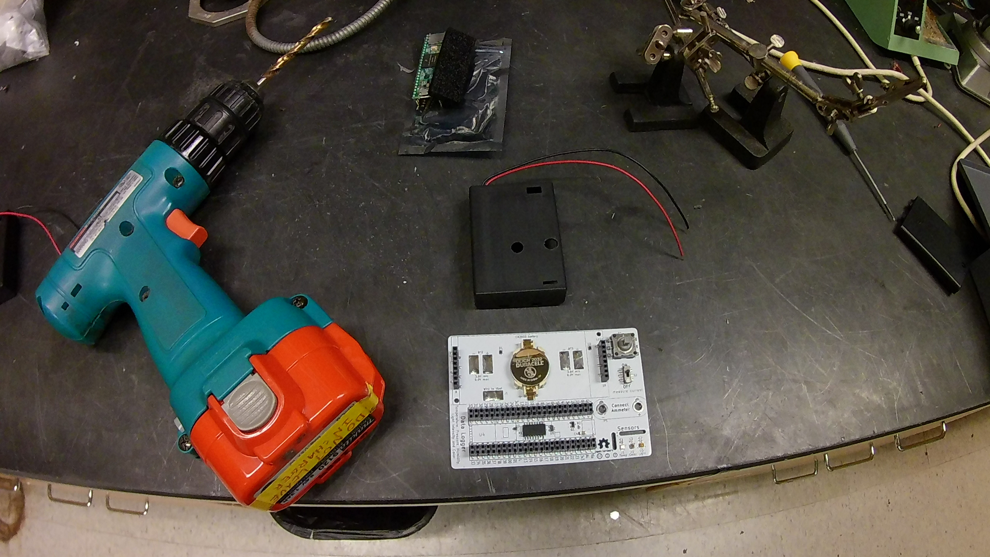

# Step 13: Connect the real-time clock battery to the Teensy

Cut a piece of wire from one of the battery pack leads, and solder the wire to the through-hole marked “Vbat” on the Teensy. Insert the Teensy into the headers and then solder the other end of the wire to the pad marked “Wire to Vbat”.

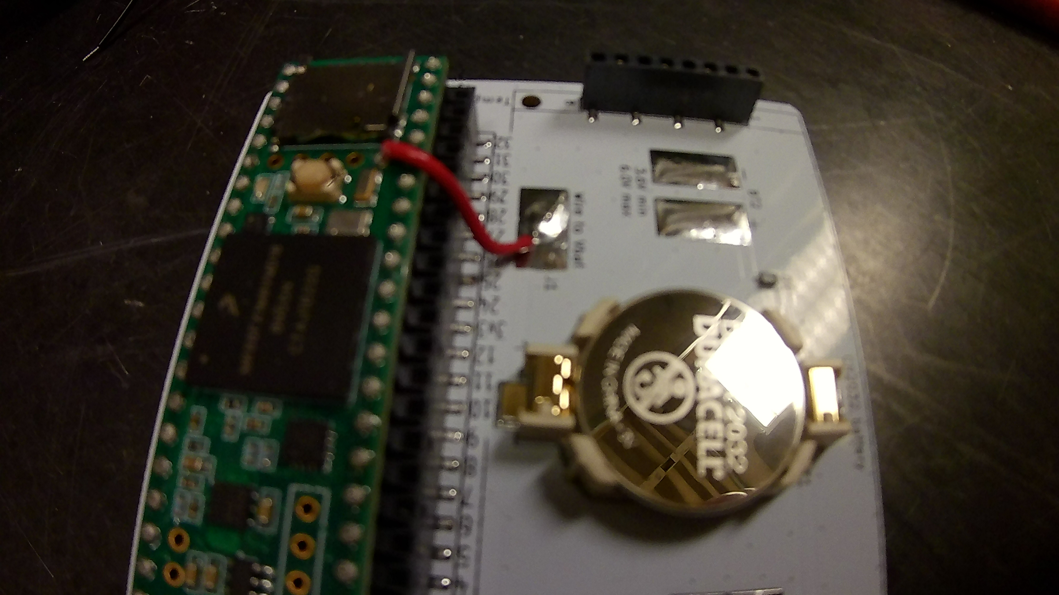

# Step 14: Glue the battery packs to the data logger

Using hot glue, trace a line of glue around the battery pack, and press it onto the PCB board. For a stronger joint, you can pre-heat the PCB board and battery pack with a hot air gun.

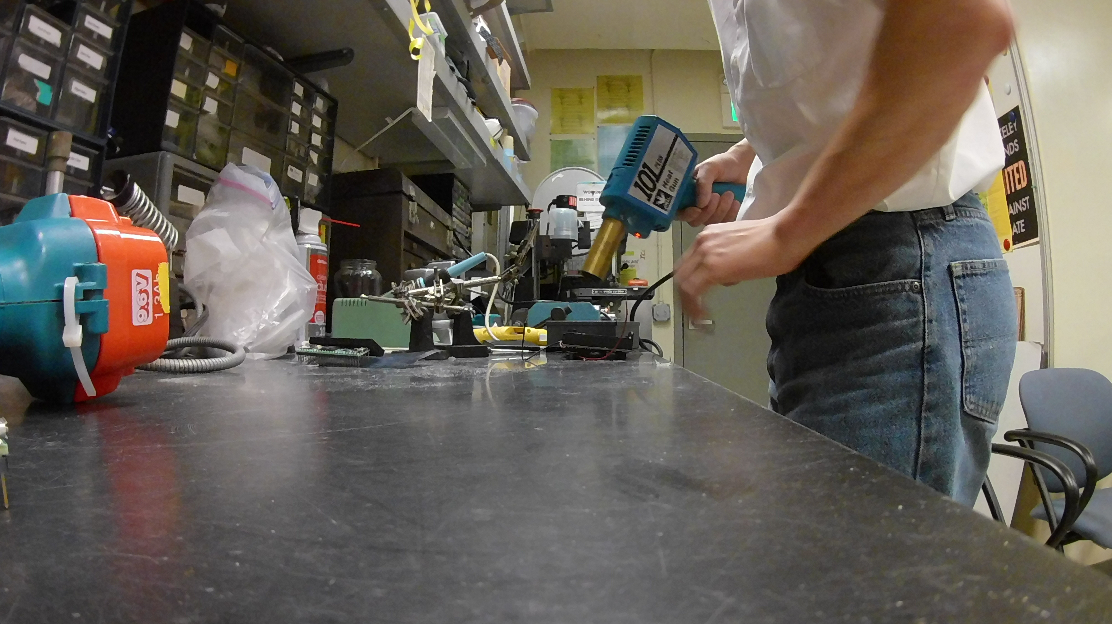

# Step 15: Solder battery packs to the PCB board and glue on standoffs

Cut the wire leads to length, and solder the wire leads to the PCB board with the red wire going to the “+” pad and the black wire going to the “-“ pad. Then bolt the standoffs to the LCD screen, apply glue to the base of the standoffs, and insert the screen into the headers. For a more secure bond, then heat the standoffs with a hot air gun to heat the standoff and board and remelt the glue.

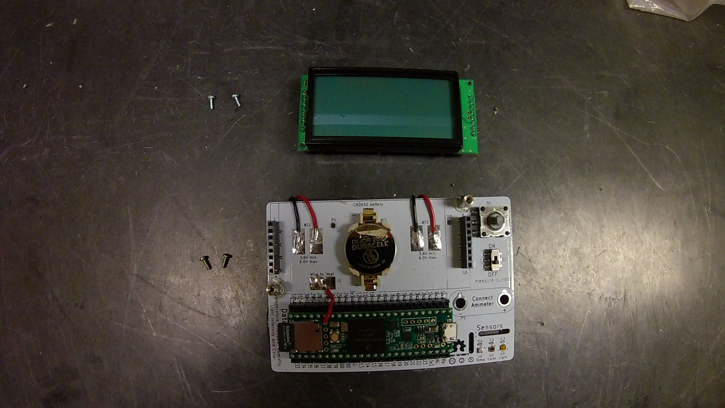

# Step 16: Finish assembly

Add 3 AA batteries to each battery pack and close the lid on the pack, and use the supplied bolt to lock the lid in place.

